
Research Proposal for a Master of Science Thesis

מאת
בועז רז
תכנית מחקר לעבודת גמר
לקראת תואר מוסמך למדעים
By
Boaz Raz
חשון ה'תשע"ז
November 2016

Abstract
Advisor: Prof. Barak Dayan
מנחה: פרופ' ברק דיין
קירור אטומים בקרבת מהוד אופטי
Sideband cooling in an optical cavity near a microtoroidal resonator
Single photon interactions with an atom through an optical cavity hold great promise in the field of quantum information. Several groups around the world have managed to trap cold Cesium atoms near the surface of a tapered fiber and microscopic resonators in order to enhance the probability of interaction ⁽¹⁾. In our scheme, an atom fountain is pointed at an optical cavity near the surface of a thin toroidal resonator, and subsequently trapped with a temperature of$\sim 400μK$. Since the trapping potential varies significantly in the tangential axis relative to the surface of the toroid, further cooling of the velocity in that direction is required in order to maintain long coherence time required for quantum memory experiment protocols. We will show that sideband cooling is the prime candid for this purpose, check its feasibility and analyze its potential.

Introduction and preliminary results
In our experimental setup, as depicted in Figure 1, cold Rubidium atoms are trapped via a Magneto-Optical Trap (MOT) and cooled down to several micro-Kelvins below a tapered optical fiber (400nm) coupled to a thin toroidal resonator. An optical cavity is placed at a distance of $\sim 200nm$ from the surface of the resonator using red and blue detuned dipole fields. We trap and cool typically 50 million atoms in a few hundred milliseconds from background vapor. In order to launch the atoms like a fountain, the frequency of the lower MOT beams is detuned relative to the upper beams. This still cools the atoms, but now in a moving reference frame, causing the atoms to accelerate in the vertical direction. The lasers are switched off after a few milliseconds, and the atoms continue their ballistic trajectory up towards the optical cavity ⁽²⁾.
Arriving at the cavity, the atoms have a velocity distribution which is not zero in the tangential direction, causing great reduction of coherence time due to the vastly changing potential in that direction. In order to increase coherence time, sideband cooling can be used.

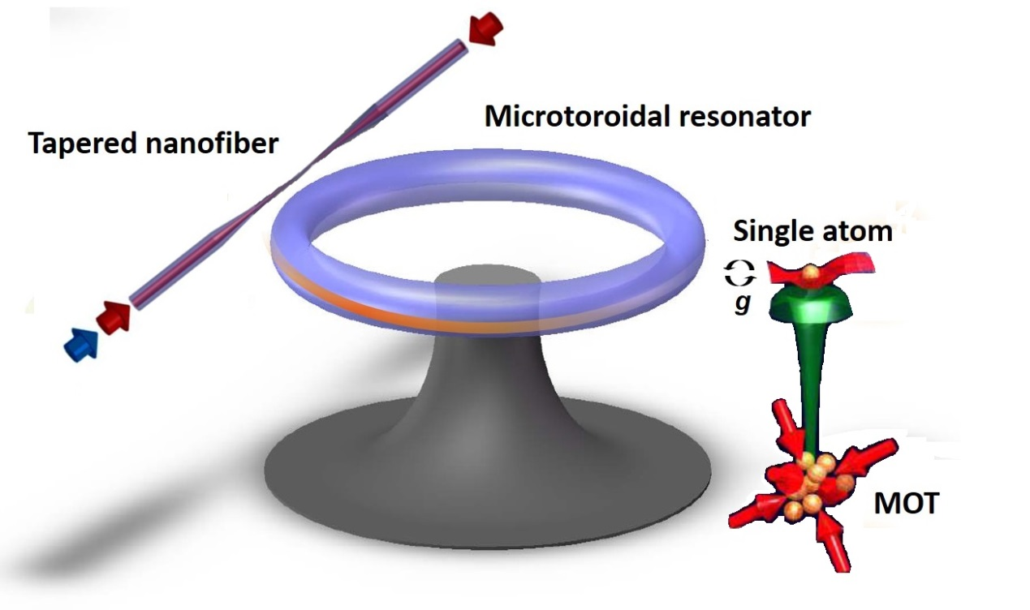
Figure 1: Experimental setup. Red and blue detuend fields (relative to $???$ transition of Rubidium atom) go through a tapered nanofiber. The fiber is thinner than the qavelength, thus supporting only the fundamanetal mode of the laser. The microtorodial resonator picks up the strong evanescent wave projected from the fiber and henhance it through Whispering Gallery Modes (WGM). The evanecesnt field of the resonator creates an optical cavity close to the toroid surface. An atom fountain whose peak trajectory lies inside the optical cavity produce a single atom for the trap. A probe beam can then be used in order to interact with the atom.

The aim of Raman side-band cooling, which enables going beyond the Doppler cooling limit, is to put the atom into the vibrational ground state of the (approximately) harmonic potential near the minimum of the optical trap ⁽³⁾. The atom has the atomic levels and the vibrational levels$|e,n>,|g,n>$, where each of the excited and ground states can have any of the $n$ possible vibrational states as depicted in Figure 2. A magnetic field is added in such a way that the Zeeman splitting between $m=-1$ and $m=0$ and between $m=0$ and $m=1$ is equal to the spacing of two levels in the harmonic potential created by the trap. Through Raman processes, an atom can now be transferred to a state where the magnetic moment has decreased by one and the vibrational state has also decreased by one (red arrows in Figure 2). Eventually the atom will be in the lowest vibrational state of the trap potential and then it will be optically pumped to the $m=1$ state. Since the temperature of the atoms is low enough with respect to the pumping beam frequencies, the atom is very likely not to change its vibrational state during the pumping process, ending up in a lower (colder) vibrational state.
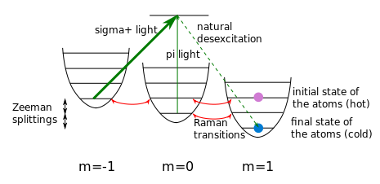
Figure 2: Sideband cooling energy diagram. Each atomic level is split into several vibrational levels. A hot atom in high vibration level can be cooled into its ground state through several Raman transitions and optical pumping.

Goals
Use sideband cooling in order to increase coherence time of atoms trapped in optical cavity near the surface of a micro toroidal resonator coupled to a tapered nanofiber, thus enabling various quantum memory experiments.

Work plan
For this scheme to work, an optical trap near the surface of a micro toroidal resonator will be constructed. We will need to model the shape and depth of the trap in order to see how far off we are from our harmonic oscillator assumption in the vicinity of the minima of the trap and account for it accordingly. We can then proceed and calculate the energy gap between two adjacent vibrational levels of the oscillator.

Next, we need to calculate the values for the magnetic fields that will split the atomic level in such a way that the energy gap between atomic levels will be identical to that of the vibrational ones. In order to pump the ground state atoms back to $m=1$ state we will need to tune our pumping laser to be resonant with the Raman transitions between the levels.

Literature

1. Strong interactions of single atoms and photons near a dielectric boundary. Alton, DJ and Stern, et al., et al. 2, 2011, Nature Physics, Vol. 7, pp. 159-165.
2. RF Spectroscopy in an Atomic Fountain. Kasevich, Mark A and Riis, Erling and Chu, Steven and DeVoe, Ralph G. 6, 1989, Physical review letters, Vol. 63, p. 612.
3. Observation of quantized motion of Rb atoms in an optical field. Jessen, Poul S., C. Gerz, P. D. Lett, W. D. Phillips, S. L. Rolston, R. J. C. Spreeuw, and C. I. Westbrook. 1, 1992, Physical review letters, Vol. 69, p. 49.

